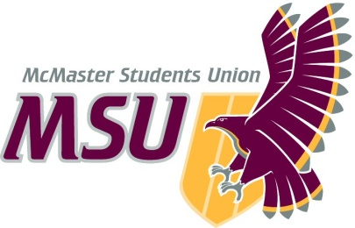. | Memo  From the…  Office of the Vice-President (Administration)
To: | Student Representative Assembly
From: | Graeme Noble
Subject: | Rescind Operating Policy – Peer Support Promotions Working Group
Date: | October 18, 2020

Dear Members of the SRA,

Operating Policy – Peer Support Promotions Working Group has run its course. The policy no longer fulfills its original mandate, nor does the group need to meet for its mandate to be fulfilled. Other bodies within the MSU already advertise the services mentioned in its operating guidelines, which eliminates the need for the committee to facilitate such promotions. As well, the policy is set to expire May 1st, 2020 (Section 4.6 of Operating Policy – Peer Support Promotions Working Group), so it’s basically just collecting dust at this point. As such, I am submitting it for a prompt rescindment.

Please let me know if you have any further questions or concerns about this change prior to the meeting so justification may be provided promptly when we convene.

Kind regards,

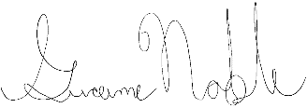

Graeme Noble
Vice-President (Administration) & Chief Administrative Officer
vpadmin@msu.mcmaster.ca
McMaster Students Union

