. | REPORT  From the office of the…  Election Department
TO: | Members of the Student Representative Assembly
FROM: | Hargun Grewal, Chief Returning Officer & Alison Hacker, Deputy Returning Officer
SUBJECT: | First Year Council (FYC) Elections Report
DATE: | November 1st, 2020

Hello Members of the Assembly,
We are excited to present our report on the results of the First Year Council Election. As per Bylaw 10 - Elections 2.1.5, the elections department is required to relay to the SRA the results of each electoral period, including recommendations of the Elections Committee.
We are pleased to say that the FYC elections ran successfully without any major issues. This year was quite unique as it was the first time, we had to run a major MSU Election entirely online all while working from home during a pandemic. Despite this, we had good student engagement and a wonderful voter turnout as well. It was also delightful to work closely with Heba Shaheed, FYC Coordinator.
Should you have any questions or concerns please do not hesitate to reach out.
Best,

Hargun Grewal (he/him) |  | Alison Hacker (she/her)
Chief Returning Officer (CRO) |  | Deputy Returning Officer (DRO)
McMaster Students Union |  | McMaster Students Union
elections@msu.mcmaster.ca |  | elections_dro@msu.mcmaster.ca

Results
Listed below are the results of the First Year Council Election ratified by the Elections Committee.

Chair: Aiman Dhilloon
Vice-Chair Events: Charlotte Chan
Vice-Chair Internal: Michelle Song*
Vice-Chair External: Maryam Sheikh*
Peter George Centre for Living and Learning Residence Chair: Henry Laing*

*Acclaimed

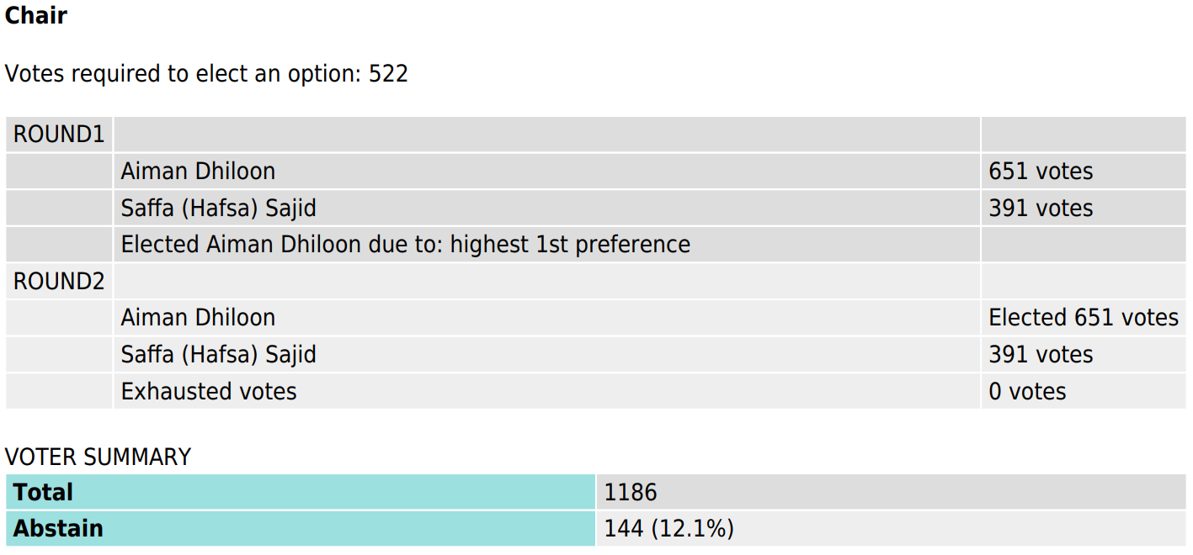
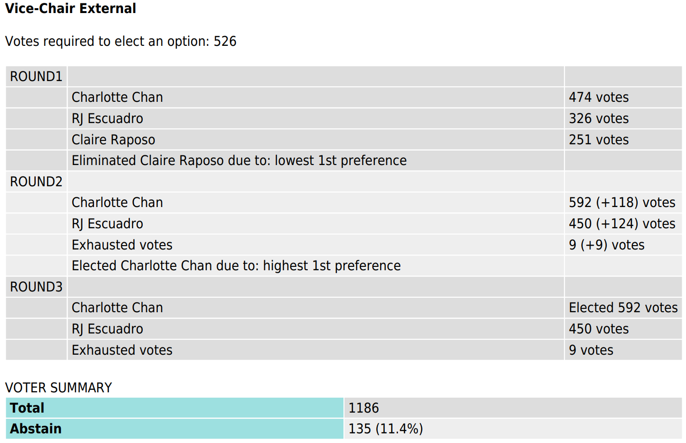

Nominations Submitted
Position | # of Nominations
Chair | 4
Vice-Chair Events | 3
Vice-Chair Internal | 1
Vice-Chair External | 1
Peter George Centre for Living and Learning Residence Chair | 1
TOTAL | 10

Candidates Running
Position | # of Candidates Running
Chair | 2
Vice-Chair Events | 3
Vice-Chair Internal | 1
Vice-Chair External | 1
Peter George Centre for Living and Learning Residence Chair | 1
TOTAL | 8

Faculty Breakdown of Candidates
Faculty | # of Candidates
Arts and Science | 0
Business | 3
Engineering | 0
Heath Sciences | 1
Humanities | 1
Science | 3
Social Science | 0
TOTAL | 8

Voter Turnout
Voter turnout for the 2020 MSU First Year Council Election was 15.9% with 1186 students voting this year. In comparison, 13% of the first-year population had turned out for the First Year Council 2019 Election. This indicates a rise of roughly 3% in first year student voter turnout.
Turnout by Country
A new aspect to see this year with everyone studying from home with online remote learning taking precedent due to the pandemic was voter turnout by country. Canada holds majority of the vote (93.5%) and students outside of Canada comprise the remainder. It will be interesting to see how we can utilize this to promote future elections so that they are able to reach constituents outside of McMaster’s usual geographic location.
Pattern of Turnout
Polling for the 2020 FYC Election occurred on September 30 from 12:00 am - 4:30 pm. Three emails were scheduled to be sent out to first years informing them to vote; immediately when the ballot opened, in the middle of the day (12:00 pm) as a reminder, and one hour before ballots closed letting them know they only had one hour to cast a vote. As you can see from the graph showcasing when votes were casted during polling, the major increases in turnout were directly after our emails were sent out. The last email we sent had a different headline than the rest and read something along the lines of “One Hour Left to Cast your Vote”. We believe writing this email with a sense of urgency and obligation is what caused the highest peak in voter turnout near the end of the election. What we would like to do in future elections is trying to send more emails like this while allowing more time for individuals to cast their vote.
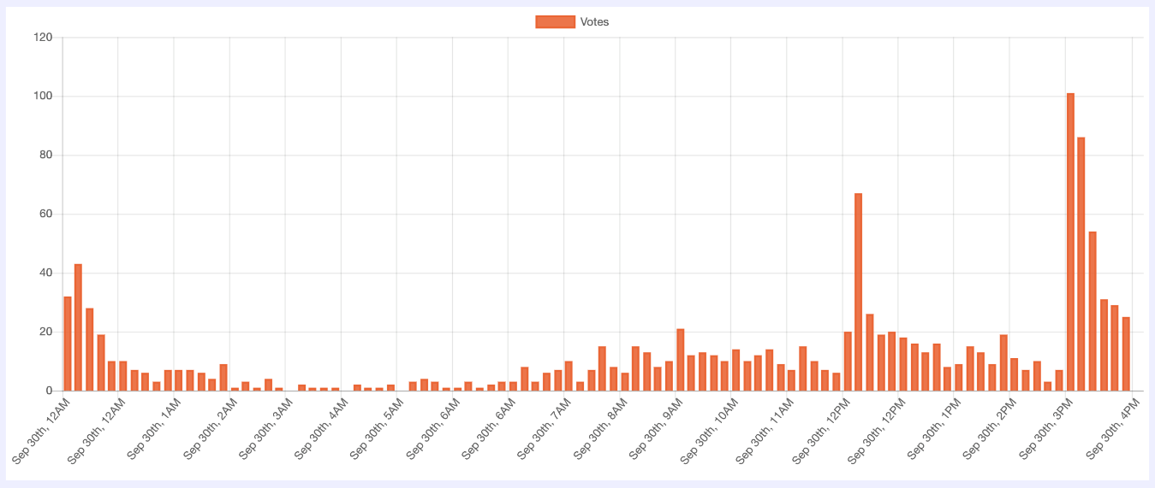
Promotional Events & Strategies
Elections 1A03
This event is designed to break down some of the information barriers that exists between students and running elections, particularly for first year students. In collaboration with Heba Shaheed, FYC Coordinator, this year we held the Elections 1A03 event online to reach out to any and all first-year students interested in getting involved. The event featured a rotational workshop similar to previous year's event, with SRA members, AVP, BOD, and previous FYC members leading rotations. This event also served as a great opportunity to promote and encourage students to run in the FYC election, as many of the FYC nominees attended the session.
Nominations Promotion
This year, we had a decrease in nominations submitted although we tried to effectively promote the of FYC positions available. We originally had nominations submitted for all positions except one, P.G.C.L.L. Residence Chair, which was great as nominations for this position only had to be extended for one day until we received a student who was interested. The reason for a decrease in the number of nominations can be due to numerous reasons such as the decreased positions we had available since usually we have 12 residence chairs, however, this year it was only one. Another factor could be overcoming the barriers in connecting with first-year students this year because of everything being done entirely online. However, the promotion for nominations ran in conjunction with promotion for Elections 1A03, which was helpful as it allowed us to simultaneously advertise both opportunities.
Updates
Rule Changes/Clarifications
The election rules for this election needed to be adapted to the current circumstances we are in due to the pandemic. Many rules were changed to consider campaigning occurring completely online as well as new prominent social media platforms students would like to utilize. In addition to this, to reduce financial concerns and barriers, the fines for the FYC election were lowered to take into account individuals from low-income backgrounds.
Challenges
Unprecedented Circumstances
This was the first major election Alison and I had to run, so with many aspects already being fairly new to us, the circumstances we are in regarding running it entirely online due to the pandemic was definitely challenging but we were able to overcome it. Many past resources and events needed to be adapted so that we could still follow through with our responsibilities.

Success
No Voting/Email Issues
Throughout the FYC election we received no emails or technical complaints submitted regarding any voting issues occurring for constituents.
Next Steps
Appeals Process Complete
The appeals process for this election has been completed as no candidates chose to appeal their violations and fines from the first elections committee fines night meeting. Due to this, the election results are official, and our first major election is complete.
Candidate Reimbursement
Our department will contact the accounting office to begin reimbursing all candidates their originally deposit minus any fines accrued during the election.

