Elections Schedule Report for 2020/2021 Year

TO: Members of the Student Representative Assembly

FROM: Hargun Grewal, Chief Returning Officer (CRO)

SUBJECT: Tentative Elections Schedule for 2020/2021 Year

DATE: September 13, 2020

Dear Members of the Assembly,

As per our bylaws, we are presenting a tentative timetable (proclamations, nomination periods, meeting dates, campaigning periods and polling dates) of the MSU Elections Cycle. If there are any changes to this schedule, an update shall be provided. Should you have any questions, please don’t hesitate to reach out to elections@msu.mcmaster.ca.

Regards,

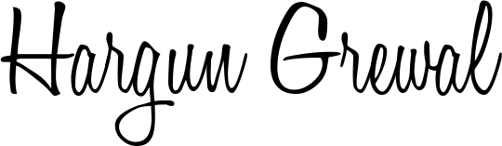

Hargun Grewal
Chief Returning Officer (CRO)
McMaster Students Union
elections@msu.mcmaster.ca

Elections Schedule
First Year Council (FYC) Elections
Proclamation September 8, 2020
Nomination Period September 8, 2020 - September 21, 2020
All Candidates Meeting September 21, 2020
Campaigning Period September 23, 2020 - September 30, 2020
Polling Date(s) September 30, 2020

SRA October By-Elections
Proclamation October 19, 2020
Nomination Period October 19, 2020 - October 23, 2020
All Candidates Meeting October 23, 2020
Campaigning Period October 26, 2020 - October 29, 2020
Polling Date(s) October 29, 2020

SRA November By-Election (if needed)
Proclamation November 2, 2020
Nomination Period November 2, 2020 - November 6, 2020
All Candidates Meeting November 6, 2020
Campaigning Period November 9, 2020 - November 12, 2020
Polling Date(s) November 12, 2020

MSU Presidential Elections
Proclamation December 2, 2020
Nomination Period December 2, 2020 - January 14, 2021
All Candidates Meeting January 14, 2021
Campaigning Period January 17, 2021 - January 28, 2021
Polling Date(s) January 26, 2021 - January 28, 2021

SRA January By-Election- (if needed)
Proclamation January 11, 2021
Nomination Period January 11, 2021 - January 15, 2021
All Candidates Meeting January 15, 2021
Campaigning Period January 18, 2021 - January 21, 2021
Polling Date(s) January 21, 2021

SRA General Elections
Proclamation February 5, 2021
Nomination Period February 5, 2021 – March 1, 2021
All Candidates Meeting March 1, 2021
Campaigning Period March 3, 2021 - March 11, 2021
Polling Date(s) March 10, 2021 - March 11, 2021

