. | Report  From the office of the…  Vice-President  (Administration)
To: | Members of the Student Representative Assembly (SRA)
From: | Graeme Noble, Vice-President (Administration)
Subject: | SRA 20K Report
Date: | November 29, 2020

Hey folks,

Please refer to the attached year plan document, as it includes all the information relevant to the status of my work in all domains of this role.

Feel free to forward me any questions you might have so that I can address them during the meeting.

Best wishes,

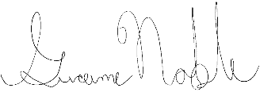
Graeme Noble
Vice-President (Administration) &
Chief Administrative Officer
McMaster Students Union
vpadmin@msu.mcmaster.ca

