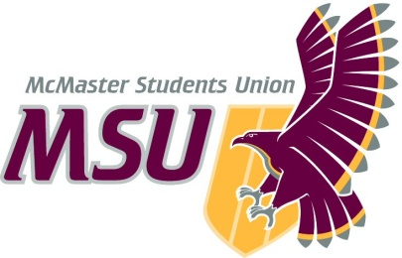. | Memo  From the office of the…  Vice-President (Administration)
To: | SRA Members and Committee Chairs
From: | Graeme Noble, Vice-President (Administration)  Michelle Brown, Associate Vice-President: Internal Governance
Subject: | Policy Organization Relocation
Date: | November 29th, 2020

Introduction
Dear Members of the Assembly,

The McMaster Students Union has been governed by documents since its creation. Since then, hundreds of different types of policy documents (i.e., the Constitution, Bylaws, Operating Policies, Corporate Bylaws, Workplace Documents, Business Practices, and Policy Papers) have been created, changed and rescinded. Surprisingly, we don’t have any recorded formal process of these procedures. The equivalent to this would be a government without any rules about how to create or change laws. Instead, up to this point, we’ve relied only on our predecessors to explain these processes to us. As can be clearly seen in our document archives, this has led to disorganized and inconsistent policies.

Proposal
This year, we’ve decided to change that. We are proposing a thorough and comprehensive bylaw to outline all the official policy processes. Not only does this increase consistency from year to year with MSU staff, it also serves to increase transparency with all the students at McMaster. The bylaw will cover the definition of each type of official document, what it governs, and the processes involved in creating, amending, rescinding, and suspending each one.

A brief outline of the policy:

- Purpose
- Definitions
- MSU Constitution Procedures
  - Amendments
  - Suspensions and Rescindments
- Corporate Bylaw Procedures
  - Adoptions, Amendments, Suspensions, & Rescindments
- Bylaw Procedures
  - Consultation & Review
  - Adoptions
  - Amendments
  - Suspensions & Rescindments
- Operating Policy Procedures
  - Consultations & Reviews
  - Adoptions
  - Amendments
  - Suspensions & Rescindments
- Employment Policy Procedures
  - General Employment Policies
    - Adoptions
    - Amendments
    - Suspensions & Rescindments
  - Full-time Employment Policies
    - Adoptions
    - Amendments
    - Suspensions & Rescindments
  - Part-time Employment Policies
    - Adoptions
    - Amendments
    - Suspensions & Rescindments
- Advocacy Policy Procedures
  - Consultations & Reviews
  - Adoptions & Renewals
  - Amendments
  - Suspensions & Rescindments
- Appendices Procedures
  - Adoptions
  - Amendments
  - Rescindments
- Policy Format
- Executive Authority

If you have any questions or concerns, please do not hesitate to reach out to us via email prior to the meeting.

Kind regards,

Graeme Noble
Vice-President (Administration) & Chief Administrative Officer
vpadmin@msu.mcmaster.ca

Michelle Brown
Associate Vice-President: Internal Governance
avpinternal@msu.mcmaster.ca

