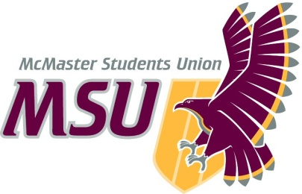. | Memo  From the office of the…  Vice-President (Administration)
To: | SRA Members and Committee Chairs
From: | Graeme Noble, Vice-President (Administration)
Subject: | Adopt Operating Policy – Welcome Week Charitable Giving
Date: | November 29, 2020

Introduction

Dear Members of the Assembly,

Charitable donations from Welcome Week (WW) have historically been redirected to the Shinerama fundraising initiative for Cystic Fibrosis. However, as WW has evolved, many felt that this approach didn’t allow for an equitable allocation of funds to other initiatives of similar importance that could also use the funds to support a charitable cause. Since Shinerama was rescinded as a Service, these charitable donations took on a new system that allowed for the reallocation of funds to various charities throughout WW.

However, since this haphazard approach didn’t have the combined power of the previously unified approach, WW stakeholders will now propose a single charity whom WW charity events will redirect donations towards to create a holistic target for all WW participants and organizers. After consulting with the Welcome Week Faculty Coordinator, the Campus Events Director, and the Maroons Coordinator in addition to the efforts of my predecessor, I propose this policy for you today with the hopes that it will be approved to enhance the processes by which we collect and distribute charitable donations.

Proposal
This policy establishes:
- Key definitions related to WW charitable giving;
- An application process for how the WW charity (WWC) shall be:
  - Advertised; and
  - Selected.
- A committee responsible for WWC application reviews and overall selection; and
- Guidelines for WWC fund collection during WW.

If you have any questions or concerns, please do not hesitate to reach out to us via email prior to the meeting.

Kind regards,

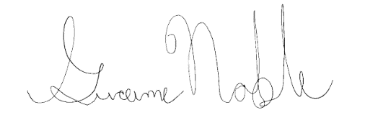

Graeme Noble
Vice-President (Administration) &
Chief Administrative Officer
McMaster Students Union
vpadmin@msu.mcmaster.ca

