Yearplan Update
. | REPORT  From the office of the…  Maroons Coordinator
TO: | Members of the Executive Board
FROM: | Hemantika Mahesh
SUBJECT: | Maroons Report 6
DATE: | November 23rd, 2020

- Virtual Food tour:
  - We decided to put out each gift card/giveaway on separate weeks to get more people to follow us over a longer period of time
  - This idea also seemed less chaotic than posting 5 different give-aways all in one week
  - This event did exactly what we wanted to do and that was increase our followers!!!
  - We started with Uber Eats because we realized a lot of people do not live in Hamilton. Furthermore, we ran into the issue of smaller businesses not offering e-gift cards. This forced us to change up our upcoming Hamilton highlights.
- Maroons Stress buster- we are collaborating with Spark for this event and it is taking place on November 27th.

Service Usage
Our Instagram has been active with our own posts, and posts promoting other services and clubs within the MSU.

Platform | Stats | Comments
Facebook | 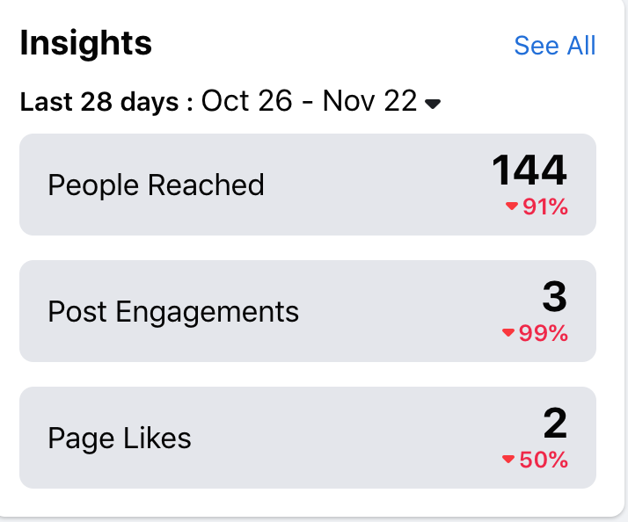 | - I am not to concerned with the decrease in percentages because when I reported last, we had recently posted out statement. Since then we have not posted on our facebook page. We will be posting promo for the destressor event on the page soon.
Instagram | 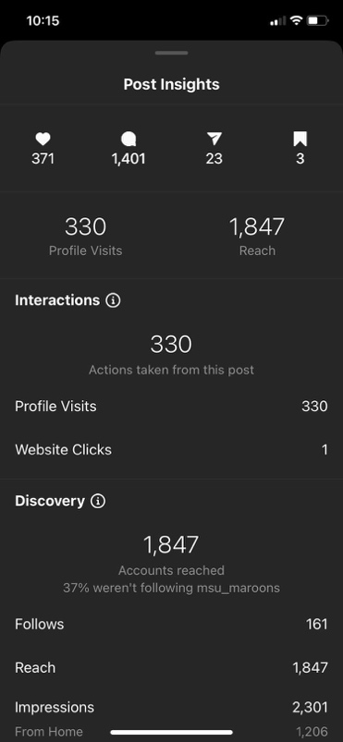  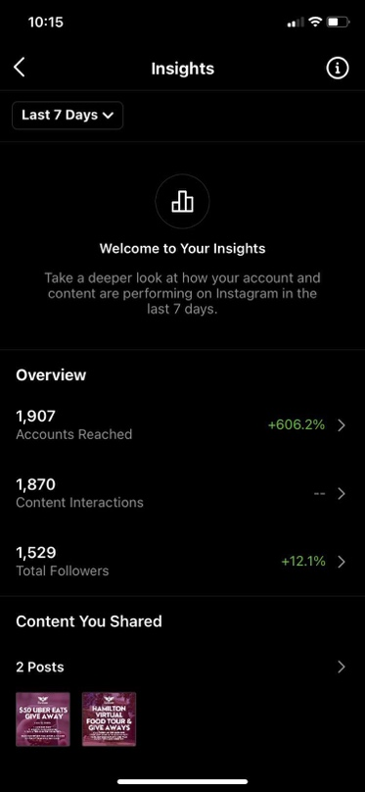 | - The give-away gave us another 161 followers and a lot of activity on our page. My hope it to keep this momentum going as we continue to post give-aways.

Past Events, Projects, & Activities
The uber eats give away will be announced later tonight! The one thing I would change from this give away for our next one is to have students share the give-away post on their personal stories to be entered into the give-away (alongside following the account and tagging friends in comments).

Furthermore, we had our smaller scale social event for the reps on November 15th. We did a speed friending style event where reps were randomly assigned into break-out rooms with other reps for 3 min with a few prompts. This encourages reps to interact with other members of their team who are not necessarily in their pod. From my experience, there are always a few members of your team of 50 that you did not get the chance to interact/get to know.

Upcoming Events, Projects & Activities
The year plan I made earlier in the year called for another destressor during December. It is definitely a busy time of year where that students struggle with the stress of exams and final deadlines. Especially this year with the added stressors of an online semester and lack of in-person activities. Once I check in with my reps and my exec team, I would make the decision to move forward with another event coming up in December.

The proposed event would be Hot Cocoa and Cookies. It would be an online event where students can come together to for a cookie-making tutorial that they can follow along to! As well, they would bring their hot beverage of choice (hot chocolate, tea, coffee, etc…) and have a chance to interact with other reps and students. Promo would go out in advance to allow for participating students to be able to obtain the ingredients needed. The cookie recipe would be a simple sugar cookie, or simple chocolate chip-cookie recipe that is quick and easy for students to make.

The social coordinators are also working on a larger social event for the Maroons team to end of the year and celebrate the upcoming winter break.

Currently Working On
- Our Stressbuster event is this Friday!
- We are having SSC come in and talk to students about any tips and advice surrounding exam time and all the stress that comes with it for the first 30 min of the sessions. Then, we are then having a few different channels open up to students!
  - Exam tips:
    - We will have a channel for each of the following courses: Chem 1A03, Philos 1B03, Psych 1X03, Math 1ZA3, Commerce 1BA3, and anatomy (there’s a few dif course codes)
    - Each channel will have 1-3 volunteers (spark and Maroons), where they will give students tips and advice from their own experiences taking these courses
  - Destressor
    - Games channel: Student will enter the channel, and will be matched with a rep/TL and a small group of students to play any virtual games scribbl io, code names, fishbowl, etc…
    - Study/chill channel: This channel will offer students a place to come and relax, talk to other reps and students, and if they want study together! Kind of like a coffee house!
    - Netflix Party channel: I feel that this allows for various shades of participation in our event.

MAROONS & SPARK EXAM EVENT! |  |  |  | * note: sessions for courses (e.g. Chem + philosophy are occuring SIMULTANEOUSLY)
Date: | Friday, November 27th
Time: | 5:00-7:00pm
Information: | Please sign up for one of the sessions (maximum 3 volunteers to run each station) and 15 volunteers for Destressor
CHEM 1A03 | Name | McMaster Email | Maroons or Spark | 5:30-6pm | PHILOS 1B03 | Name | McMaster Email | Maroons or Spark
EXAMPLE | Zendaya | _______@mcmaster.ca | Spark
PSYCH 1X03 | Name | McMaster Email | Maroons or Spark | 6-6:30pm | MATH 1ZA3 | Name | McMaster Email | Maroons or Spark
COMMERCE 1BA3 | Name | McMaster Email | Maroons or Spark | 6:30-7pm | KIN 1A03 / HTHSCI 1H06 | Name | McMaster Email | Maroons or Spark
DESTRESSOR!! | Name | McMaster Email | Maroons or Spark | 6-7pm

Budget
ACCOUNT CODE | ITEM | BUDGET / COST
5003-0120 | MAROONS - OFFICE SUPPLIES | $50.00
 | TOTAL SPENT IN LINE | $0.00
 | REMAINING IN LINE | $50.00
6102-0120 | MAROONS - ANNUAL CAMPAIGNS | $450.00
 | TOTAL SPENT IN LINE | $0.00
 | REMAINING IN LINE | $450.00
6415-0120 | MAROONS - VOLUNTEER APPRICIATION | $750.00
 | TOTAL SPENT IN LINE | $0.00
 | REMAINING IN LINE | $750.00
6501-0120 | MAROONS - ADVERTISING & PROMOTIONS | $1,000.00
 | TOTAL SPENT IN LINE | $0.00
 | REMAINING IN LINE | $1,000.00
6603-0120 | MAROONS - SPECIAL PROJECTS | $750.00
 | Uber Eats Gift Card | $50.00
 | TOTAL SPENT IN LINE | $50.00
 | REMAINING IN LINE | $700.00
6633-0120 | MAROONS - UNIFORMS | $7,000.00
 | Westend Sports | $1,600.00
 | TOTAL SPENT IN LINE | $1,600.00
 | REMAINING IN LINE | $5,400.00
6804-0120 | MAROONS - MEMBER TRAINING | $500.00
 | SACHA | $450.00
 | TOTAL SPENT IN LINE | $450.00
 | REMAINING IN LINE | $50.00
TOTAL BUDGETED DISCRETIONARY SPENDING | $10,500.00
TOTAL ACTUAL DISCRETIONARY SPENDING | $2,100.00
REMAINING DISCRETIONARY SPENDING | $8,400.00

Volunteers
During the social I had an opportunity to spend some one-on-one time with a few of my reps and it was a really great experience to connect and interact with them. I have felt that it has been difficult to connect with all members of my team authentically because during events I am usually running logistics or managing any issues that arise, vs actually working with the reps. I also do not have a pod and so this social event was really great to facilitate more connection between myself and individual reps. I feel that this is important to dismantle any power dynamics that may exist between the reps and the LT team.

Current Challenges
I am struggling to keep the volunteers engaged, motivated, and appreciated. The online aspect of the service this year has definitely had an impact on team dynamic. I am grateful for their enthusiasm and during events, but the team does feel less connected than in previous years. I am learning to adapt to the changes of this year, and how to accept the differences that these changes bring.

Successes
I am really excited about all the activity our Instagram give-away has brought to our page, and the increase in followers. I definitely think the increase in followers will help our engagement when we reach out to the student body for events and activities and promo via our Instagram.

