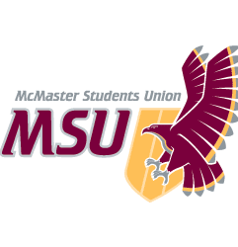
REPORT
From the office of the…
Kinesiology Caucus

.

TO: Members of the Student Representative Assembly
FROM: Charlie Violin, Manpreet Chopra
SUBJECT: SRA 20J Report
DATE: November 15, 2020

Progress on Year Plan

- Highlighting Kin Students in MSU Services
- Helped to Advocate for mandatory anti-racism and inclusion modules with Kinesiology Society

Past Events, Projects, & Activities

- Move for a Cure w/ Kin Society, See 10 Reps, Do 10 Reps
- SoBi Bike campaign

Upcoming Events, Projects, & Activities

- Working with Kin Society VP Academic
  - some courses for Winter 2020 have been canceled and we are working on getting feedback from students and alumni on why this course should continue to run
  - Kinesiology Thesis course looking into extending it to a 9 or 12 units rather than 6, as most programs on campus have thesis courses that give more credit to students for their hard work

Current Challenges

- Coordinating a date for an SRA Kin virtual event
- Low engagement in office hours, working with Kin Society on ways to best approach students while encouraging them to come out to virtual office hours

Successes

- Increased Awareness and Engagement on Social Media Platforms

- Advocated for a new position on Kin Society to promote accessibility and equity in events and on the society itself. Inclusion and Diversity Coordinator is a brand new position on KS

Best,

Manpreet Chopra
SRA Kinesiology Caucus Leader McMaster Students Union
srakin@msu.mcmaster.ca

