POLICY PAPER
Ancillary Fees

Prepared by:
Blake Oliver, Vice-President Education, 2016-17 Jordan Cole, SRA Social Sciences, 2016-17
Esra Bengizi, SRA Humanities, 2016-17 Ashley Eom, SRA Health Sciences, 2016-17
Urszula Sitarz, SRA University Affairs Committee Member, 2016-17

With Files From:
Jeevika Goyal, MSU University Affairs Research Assistant 2016-17
Aryan Pour-Bahreini, MSU Provincial and Federal Affairs Research Assistant 2016-17

Approved 16P

Table of Contents
Introduction 3
Definitions 4
Transparency 6
Faculty Society Fees 6
University Ancillary Fees 6
Opt-Out Fees 8
Student Control 9
Residence Fees 9
Fees for Keys in Residence 10
Faculty-specific Fees 11
Fair-Cost Sharing 13
Student Contribution to Operating Costs 13
Graduation Fees 14
Student Contribution to Capital Projects 15
Additional Tuition Fees 16
Ombuds Office 17
Athletics Centre 18
Field-Trip Fees 18
Textbooks 19
Courseware 19
Physical Learning Materials 20
Digital Learning Materials 21
Medical Documentation 22
Work-Integrated Learning Fees 23
Grade Appeal Fees 23
Policy Statement 25

Introduction
At McMaster, as well as across the province, undergraduate students are not only paying high tuition costs - they are also shouldering the burden of high ancillary fees. Ancillary fees are defined by the Ministry of Advanced Education and Skills Development as "a fee imposed or administered by a given institution, or one of its constituents parts, in addition to regular tuition fees, which a student pays for a service or product". Over the past four decades, through a period of tuition regulation, students have seen high increases in ancillary fees to compensate for operating costs.
Through Ontario's Tuition Fee Framework and Ancillary Fee Guidelines for Publicly Assisted Universities, 2013-14 to 2016-17, any ancillary fee related to academic instruction or evaluation is considered a "tuition-related compulsory ancillary fee", which is illegal. This paper seeks to address some tuition-related compulsory ancillary fees that still exist, and propose solutions to rectify each situation in which students at McMaster are paying tuition-related compulsory ancillary fees. In addition, this paper seeks to ensure that students are engaging in a process of fair-cost sharing for all student services and initiatives on campus. This paper will also investigate the need for a transparent use of ancillary fees, and accountability of the groups collecting, administering, and using these fees to the students.
This paper will offer a series of recommendations that are representative of the principles and concerns of McMaster full-time undergraduate students. These recommendations are mainly aimed at McMaster University, but occasionally at the provincial government or other stakeholders. This paper emphasized evidence-based policy solutions with the following goals in mind: improving transparency and accountability of ancillary fees, mandate student control and governance autonomy in regards to changes in these fees, and effectively implementing a fair-cost sharing model for services.
In addition to this paper, the MSU is a member of the Ontario Undergraduate Students Alliance, which lobbies to the provincial government on behalf of Ontario undergraduate students. Further to this paper, the MSU supports all recommendations stated in OUSA's paper on Ancillary Fees, 2016.

Definitions
The following definitions are the same definitions as outlined in the Ontario Ministry of Training, Colleges, and Universities Tuition Fee Framework and Ancillary Fee Guidelines for Publicly-Assisted Universities, 2013-14 to 2016-17:
Ancillary Fee:

An ancillary fee is defined as a fee imposed or administered by a given institution, or one of its constituent parts or its federated or affiliated institutions, in addition to regular tuition fees, which a student pays for a service or product.
Compulsory Ancillary Fee:

A compulsory ancillary fee is defined as a fee imposed or administered by a given institution, or one of its constituent parts or its federated or affiliated institutions, in addition to regular tuition fees, which a student is required to pay in order to enroll in, or successfully complete, any credit course.
Compulsory Course:

A compulsory course is defined by the Ministry as a course which a student is required to take in order to fulfill the requirements of his or her program or degree.
Student Governments:

The term student governments is defined as the minimum number of student organizations which have both elected leadership and by-laws setting out their methods of operation and which, when viewed in combination at an individual institution, represent all students who are eligible to be represented by a student organization.
Student Government Representatives:

The term student government representatives is defined as one or more representatives from each of the student governments as defined above.
Compulsory Tuition-Related Ancillary Fees:

A fee which is levied to cover the costs of items that are normally paid for out of operating or capital revenue. Institutions are not allowed to charge compulsory tuition-related ancillary fees. This includes any fee related to the confirmation of credential completion and any fee for
providing a graduation certificate.

Compulsory Non-Tuition-Related Ancillary Fees:

A fee which is levied to cover the costs of items which are not normally paid for out of operating or capital revenue. All compulsory non-tuition-related ancillary fees levied by a university or related institution must:
be approved by the governing body; and

be announced prior to collection through the institution's calendar and/or published fee schedule(s).
The fee announcement must provide a breakdown of all compulsory non-tuition-related ancillary fees. The announcement must explain the purpose(s) of the fee sufficiently to allow students to understand the materials, services or facilities that have been rendered through payment of the fee(s).
When introducing a new fee or modifying an existing fee, institutions must:

Provide a full rationale for each fee, including the reasons for its compulsory nature, any information necessary for student governments and governing bodies to understand the purpose of the fee, the costs included in calculating the fee level, the students for whom the fee will be compulsory, the total revenue available from the fee and the process used for developing the fee; and
Respond with a full explanation to inquiries made by student governments in connection with concerns about any ancillary fee.

Compulsory non-tuition-related ancillary fees can neither be increased nor expanded to include new fees except through the implementation of an ancillary fee protocol. Introduction of new or increases to existing compulsory non-tuition-related ancillary fees can only be implemented as provided for in an ancillary fee protocol or through an exemption to an ancillary fee protocol.
Ancillary Fee Protocol:

A formal agreement between the institution’s administration and student government representatives which set out the means by which students will be involved in decisions to introduce a new or modify an existing compulsory non-tuition related ancillary fee.

Transparency

Faculty Society Fees
Principle: All fees collected by faculty societies from students should be spent in a transparent manner.

Concern: Students pay annual ancillary fees to their faculty societies, but are often unaware of how faculty societies spend their money.

Recommendation: Deans of each faculty should ensure that their respective student faculty societies are transparent with financial information by posting budgets and financial statements publicly.

Recommendation: Faculty societies should work to education students on financial breakdown of their student fees by posting on Mosaic, social media pages, and hosting in- person information sessions.

It is vital that students pay compulsory fees towards their faculties as they go towards funding for events such as welcome week, which can be essential to a student’s undergraduate experience. These events are often where students can meet other students from diverse backgrounds as well as feel like they are part of a community. Although many students are unaware that they pay fees to their faculty societies, in order to maintain integrity and respect the agreements that were formed between students and universities, it is essential that all fees be transparent.
It is essential that all faculty societies engage with students and produce methods in which they are able to reveal the breakdown of where student money is being allocated. Financial information should be easily accessible to students and there should be a breakdown of where fees are being allocated. Students believe that this type of engagement can occur via posting financial information on high-traffic areas such as Mosaic and social media, and can also be done in person in the form of in-person information sessions.

University Ancillary Fees
Principle: All ancillary fees collected by the University from students should be spent in a transparent manner.

Concern: Students are not able to access information on how compulsory ancillary fees collected by the University are spent.

Recommendation: McMaster University should ensure that uses of student ancillary fees are transparent by posting budgets and financial statements of student ancillary fee use publicly.

Recommendation: McMaster University should work to educate students on financial breakdown of their student fees by posting on Mosaic, social media pages, and hosting in- person informational sessions.

It is recognized by many that ancillary fees go toward supporting non-academic services but it is acknowledged by many that there is a lack of transparency on how fees are levied.
McMaster University acknowledges the importance of student services being funded through

ancillary fees but to the average student, there is a lack of transparency that illustrates exactly how fees are spent.
This is unfair for students as the governance of ancillary fees must remain in the hands of students and access to how fees are spent is not easily accessible. CAF agreements were formed amongst many universities across Ontario due to the demand from student lobby groups in the 1990’s to prevent universities from monetizing education and gaining revenue from students. Therefore, it is essential for universities to address these student concerns that are also relevant today. It is their duty to be transparent and by respecting the agreements that were made between universities and students.
Therefore, students believe that it is essential that financial information be readily available to students in an accessible and easy manner. It is critical that the University informs students on where their money is being allocated and this should be accomplished in a manner where university presence is online and in person. For instance, the McMaster Students Union provides a breakdown of fees online at www.msumcmaster.ca/yourmoney, which shows the following graphics:

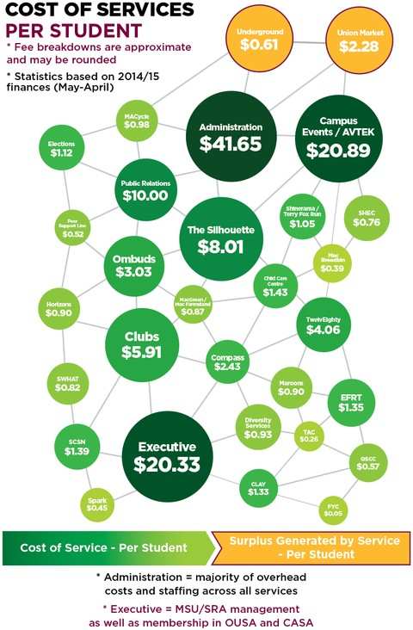
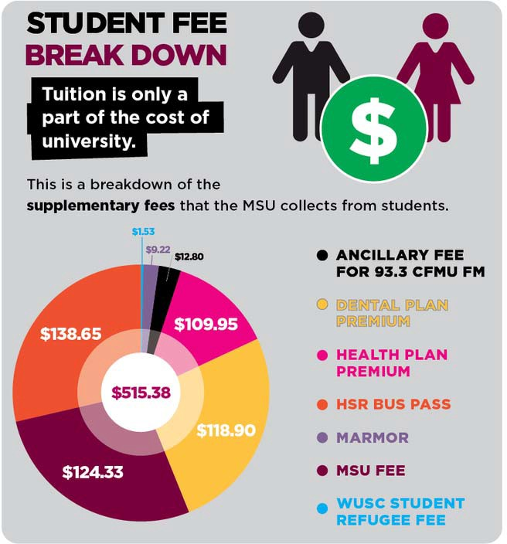

These graphics make it easy and accessible for students to understand where their additional fees are going. Students believe that the University should adopt a similar system to explain the breakdown of student ancillary fees administered by the University.
Students are concerned with the transparency of the Student Services fee. This fee amounts to $4.38 per unit, to a maximum of $131.40 per academic year. In addition, full-time undergraduate students also pay an Athletics & Recreation Activity Fee of $112.25, as well as a

Student Health Service of $57.43. With fees such as Athletics & Recreation and Student Health Service, the name of the fee as it appears on a student's MOSAIC accounts is clear - one is for athletics and recreation, and the other is for the student wellness centre. However, the Student Services fee is less clear. In addition, Schedule A of the MSU - McMaster CAF agreement outlines the breakdown of the Student Services Fee - some going to the Student Wellness Centre, some to the Student Success Centre, and some to Athletics & Recreation. In order to be most transparent, students believe that the breakdown of fees - how much each student is contributing to each arm of Student Affairs - should be published each year, in order to ensure transparency.

Opt-Out Fees
Principle: Students should be made aware that they have the choice to opt-out of specific fees and receive their money back.

Concern: Many students are unaware that they can opt-out of certain fees and are also unaware that they receive money back after opting-out.

Concern: Some students miss the date to opt-out of fees and are therefore unable to receive money back.

Concern: For some fees in which students in which students can opt-out, the process can only be done in person, which may create a barrier to students accessing the opt-out option.

Recommendation: For fees in which students can opt-out, groups should increase publicity about the opt-out during the opt-out period by posting on Mosaic, social media, and hosting in-person informational sessions.

Recommendation: For fees in which students can opt-out, there should be a centralized appeals process for when the opt-out deadline is missed.

Recommendation: For fees in which students can opt-out, there should be an opportunity for students to do so online via Mosaic.

Some ancillary fees at McMaster are opt-out - such as the OPRIG fee. It is essential that students are aware that they can save money by opting-out of certain fees. Additionally, it is essential that students can access a fair and easy-to-navigate system when opting out of fees.
Groups who charge fees in which students can opt-out should increase publicity on the option to opt-out by making this information readily available by posting it online on Mosaic, various social media outlets, and engaging with students in-person via informational sessions. In addition, there are some cases in which students may miss opt-out deadlines, either due to a lack of promotion, or because a student’s status changed (i.e. a part-time student becoming a full-time student after the opt-out deadline has passed). Because of these cases, students believe that a centralized body should receive and decide on appeals for when an opt-out deadline is missed. An option for this body could be the Ombudsperson. Students believe it is essential for this body to be non-partisan, as groups who benefit from a low opt-out rate may be less likely to grant an appeal for a fee.

Finally, there are some opt-out processes that cannot be done online, and only in person (for instance, the OPIRG fee). Students believe this creates less accessibility in the opt-out process. Students would like to see the possibility to opt-out of all fees online via Mosaic student accounts, to be most transparent and accessible to students.

Student Control

Residence Fees
Principle: Students in residence should have autonomy over ancillary fees for the purpose of student life.

Concern: The Residence Life Activity Fee, an ancillary fee for all students in residence for the purpose of enhancing student life, was levied onto students without student consultation.

Recommendation: Any future changes to the Residence Life Activity Fee should be put to referendum of all residence students, with clear parameters for the use of the fee.

Recommendation: Students should have considerable control over the use of the Residence Life Activity Fee.

Students who choose to live in residence are charged between $4,695.00 - $7,700, according to the following table:
Table: Cost of Residence at McMaster University in 2013-14

Type of Room | Cost
Bunk and Loft Triple Room | $4,695.00
Quad Room | $5,235.00
Double/Triple Room | $5,550.00
Double Room with Washroom | $5,970.00
Single Room | $6,260.00
Single Room with Washroom | $6,680.00
Bates Apartment Room | $7,195.00
Mary E. Keyes Suite Room | $7,700.00

In addition to the above fees, students also pay a meal plan fee, ranging from $2,215 to
$3,690 annually. Students recognize the validity of these costs, and the right of the University to charge students appropriate costs for living and food. Students do not seek to control residence fees or meal plan fees. However, students feel that it is appropriate for consultation to occur on fees imposed for the purpose of student life in residence.
Until 2016, the Inter-Residence Council (IRC) was a student organization on campus that provided a governance structure, resources for advocacy, and programming for student life in residence. To provide these services, $46.09 was levied from each residence student. This fee was never put to referendum and was instead established through McMaster University’s governance structure, as it does not fit the definition of a compulsory ancillary fee as defined by the CAF agreement. When the IRC's status as a recognized student organization was

revoked in 2016, this fee continued to be charged to residence students under the name "Residence Life Activity Fee".
Students believe that residence students should have autonomy and be consulted on all fees relating to student life in residence. A fee such as the Residence Life Activity Fee, which clearly exists to better student life in residence and was formerly managed by a student organization, fits into this definition. Therefore, students believe that any future increases or decreases to the Residence Life Activity Fee should be put to a referendum to residence students, like any other compulsory ancillary fee. As well, this fee in the past was entirely managed by students. With this in mind, students should have considerable control of the use of the Residence Life Activity Fee, as it exists to benefit them specifically. McMaster Residence Life should sign a Memorandum of Understanding with the McMaster Students Union to ensure that student control of this fee is recognized moving forward.

Fees for Keys in Residence
Principle: All charges to the student account and its amount should be justifiable to reflect the service or product associated with it.

Concern: Penalty fees for being locked out of residence rooms is administered in an unfair and unjustifiable manner.

Recommendation: The Housing and Conference Services should remove the penalty fees for lock out keys.

Penalty fees charged to students for missed appointments, lost keys, or late payments must be administered fairly.
Currently, the Housing and Conference Services charge students lock out fees in the incidences where students accidentally lock themselves out of their residence rooms or suites with the keys inside. The penalty fee increases substantially with every two incidences of lock out, with the fee hiking up to $20 as shown below. Firstly, this fee is not reflective of the process it takes to recover the students’ keys inside. In the case of lock out, students must report to their Quad office and request for a lock out key, which they can sign out for 20 minutes. There is no cost associated with this process of signing out a readily available key in the Quad office. Secondly, being locked out of residence rooms and suites is purely accidental. Penalty fees with the purpose of deterring students from late tuition payments and missing appointments is reasonable; however, the lock out fee is unjustified as being locked out of a room is unintentional and unpreventable.
Students should not be penalized financially for incidences that arise accidentally and the hiking fee model with every two offences is an unfair burden to students who already pay considerable amount to live on residences. The Housing and Conference Services must abolish the fee to better accommodate for the needs of students in residences.

Incidence of Lock Out | Lock Out Fee
Lock Out 1 | Free of charge

Lock Out 2 & 3 | $3
Lock Out 4 & 5 | $5
Lock Out 6 & 7 | $10
Lock Out 8 & 9 | $15
Lock Out 10 & following | $20

Faculty-specific Fees
Principle: Governance of all ancillary fees should remain in the hands of students.

Principle: Faculties and societies do not currently operate with any compulsory ancillary fees agreement; this leads any society or faculty to be defenceless to increasing faculty specific fees when a potential addition or improvement to services is imminent.

Concern: Faculties and societies not having a clear pathway with regards to faculty-specific ancillary fees leaves an opening that cannot be protected; this can result in students being unable to enact change within their respective societies and furthermore pay increased sums into ancillary fees.

Recommendation: Each faculty society should create a compulsory ancillary fee agreement with their respective faculty to provide a high degree of protection that includes accountability and control over student fees.

The current model for faculty-specific fees and student societies is neither consistent nor conducive when held in comparison to other ancillary fees that students currently pay.
According to McMaster’s financial information, the lowest fee that currently exists is $28.11 for Arts & Science students and $200.00 for Commerce students. With such a vast difference in fee size, coupled with the notion that there is nothing to protect faculties when it comes to the fees being increased, action must be taken.

Table: Faculty Specific Society/Support Fees

Faculty | Cost
Arts & Science | $28.11
Bachelor of Health Sciences (Honours) | $30.00
Commerce | $200.00
Engineering | $190.01
Humanities | $60.00

Medical Radiation Science Collaborative  Fee | $143.25
Nursing | $189.92
Science | $50.00
Social Sciences | $65.60

In McMaster's Financial Accountability Policy for Student Organizations that receive Free Remittances from the University, a process is detailed in which independent student organizations (ISOs) such as faculty societies are able to collect a new fee from students. That process is as follows:

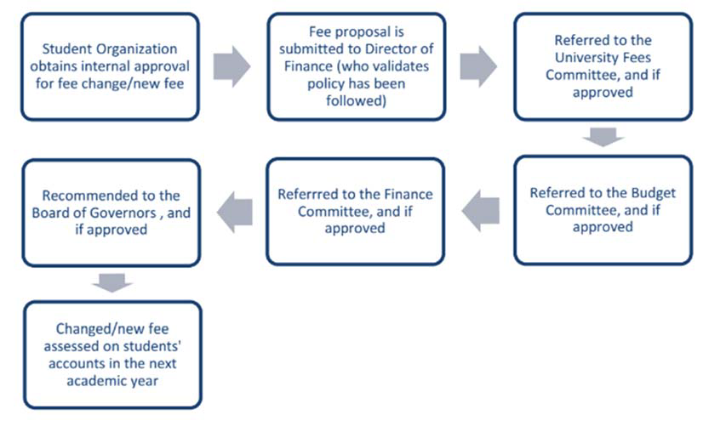

While this process is outlined for student organizations, there is no process outlined for faculties themselves to increase a student fee. For instance, in 2016, a proposal was put forward to increase the fee for the Science Career, Co-op, and Experiential Education Office (SCCE). This proposal was put forward to students in the form of a referendum, the same way as the process above. However, this is not a fee from an ISO - it is a fee from a University office.
Students believe that the solution for faculty-specific fees and student societies is to create a compulsory ancillary fee agreement that allows for increased defense for students in the vein of accountability and control over how student fees are increased for each faculty and respective student faculty society. This compulsory ancillary fee agreement would lead to better function with respect to enacting change in a society or faculty and maintain that the control of ancillary fees is held by students.

Fair-Cost Sharing

Student Contribution to Operating Costs
Principle: All willing and qualified students should be able to access and excel at McMaster University.

Principle: Students should not have to inequitably cover the costs of operational funding for universities.

Concern: Compulsory ancillary fees have been used as a source of increase operating revenue by all universities in Ontario, including McMaster University, and have increased substantially above inflation over the past two years.

Concern: Students are paying increasing amounts of money towards ancillary fees with little to no assistance from the University.

Recommendation: The provincial government must increase operational funding such that operational funding is not disproportionately reliant on ancillary fees.

Recommendation: McMaster University must contribute increasing amounts to services and goods that benefit the university community. This will ultimately help to strengthen accountability with the university.

Access for all willing and qualified students to Ontario’s post-secondary education system is the capstone of students’ belief and vision for the province. The prodigious and most obvious barrier to this access is in terms of financials- the fees, tuition and non-tuition, that students pay to attend an institution in Ontario. Other than students, the largest sources of funding for operating revenue is operating grants that are distributed by the provincial government. This system of two main contributors- the public, and the individual- is known as “cost-sharing”, this is based on the belief that there is a high rate of return to higher education, and it is fair for individuals who benefit from receiving post-secondary education to contribute to the costs associated with advancing that education.
Over the last twenty years, large increases to tuition and ancillary fees have tipped the scales from a model of fair-cost sharing and publicly funded institutions to an unfair burden of costs to students, this ultimately resulting in what are not called “publicly-assisted” institutions.
Research conducted by the Ontario Undergraduate Student Alliance shows that in 2014-16 students in Ontario were the largest funder of Ontario’s post-secondary institutions, contributing 44% of operating costs versus the government’s 41%i While increases to tuition have caused the dominant share of this inequity, ancillary fees have also risen to an all-time high of 6% of operating revenue, this in comparison to 1% in 1991-92. The graph below demonstrates changes to student and government contribution to post-secondary institutions in Ontario since 1980.

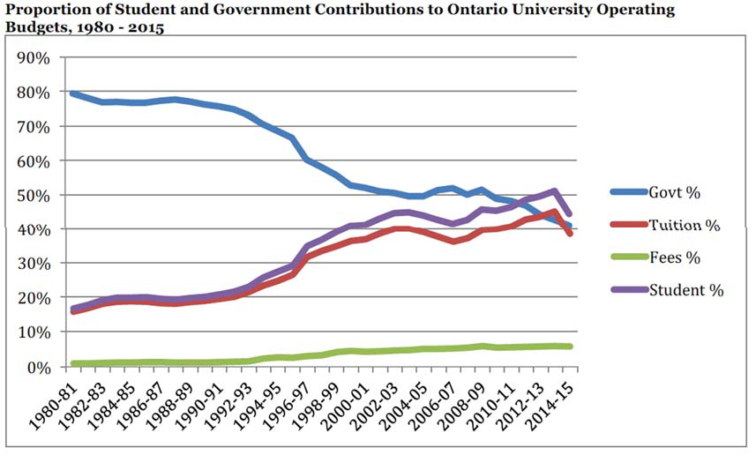

Steep increase in ancillary fees over the past three decades shows undeniable proof that as government contribution has declines; institutions have been unable to provide services to students. The costs of these services have instead been placed on the shoulders of students. While students of McMaster understand that some ancillary fees are legitimate costs that are fairly charged to students, they do not agree that they should be shouldering such a large burden of operating costs in publicly assisted institutions.
Fair-cost sharing is a principle that students also believe should be extended beyond operational funding costs at universities to services provided to the university community. Services such as the Ombuds office, peer support services, health services, athletics and recreation facilities and programming, and many more are funded generally in part or fully by undergraduate students, though they are enjoyed by the entire university community.
Students believe that the principle of fair cost sharing should be applied to services, and that groups accessing these services should contribute comparable amounts to said services.
In order to return to a system of fair cost sharing, Ontario, as a province must invest in post- secondary institutions by increasing operating grants, thus reducing the reliance of institutions on student fees. It is clear that ancillary fees did not rise in Ontario prior to funding cuts in the 1990’s, which reduced the ability of institutions to provide both essential and important student services. Students feel that a reinvestment in institutions from the province will relieve the burden of fees and eliminate barriers of financial inaccessibility.

Graduation Fees
Principle: All graduating students from McMaster University should have the option of attending a graduation ceremony to receive their diploma.

Concern: In order to attend this graduation ceremony, students must pay a $40.00 service fee which could be a financial barrier and deter students from attending.

Recommendation: McMaster University should remove of the cost of this service fee to allow more students to attend their graduation ceremony.

Graduation is the culmination of a student’s undergraduate career and one of the greatest achievements a student can obtain. The graduation ceremony is a chance for students to be recognized for and celebrate their accomplishments.
The MTCU University tuition framework guidelines have set that fees for convocation ceremonies are exempt from requiring a protocol. This lack of regulation of ancillary fees in terms of a fundamental aspect of the University experience results in unnecessarily high fees for students. McMaster students must pay a $40.00 service fee to attend their ceremony and this cost could be a financial burden to students. To avoid this additional financial burden, especially after completely at least three years of undergraduate studies, students will not attend their ceremony.
The MTCU guidelines prohibit institutions from charging any fee to obtain a graduation certificate. This is currently not followed at McMaster as students are faced with the choice of
$40.00 to attend their convocation ceremony or $25.00 to have their diploma mailed. Therefore, the MSU recommends that McMaster University remove the graduation service fee. The elimination of this fee will allow any student to attend their ceremony by removing part of the burden that students have throughout their entire undergraduate careers.

Student Contribution to Capital Projects
Principle: Capital projects that enhance student development, such as student centres, health, and athletic facilities, should be eligible for provincial government funding and financed fairly amongst all stakeholders.

Principle: Students should have input into the management and allocation of space in facilities to which they have financially contributed.

Concern: Undergraduate students at McMaster University have a disproportionate burden in financing buildings and expansions that benefit the entire university.

Recommendation: The cost remaining after any government funding available for student- focused projects should be responsibly shared between university and all student groups on campus.

Recommendation: For capital projects that students are contributing a considerable amount, a memorandum of understanding (MOU) should be created to haves student representation that is reflective of their financial contribution.

Most academic buildings and facilities in universities are eligible for federal and provincial funding as they directly support the core academic function. However, ancillary facilities such as athletic and recreation facilities, student centres, and health centres are exempt from such support. However, most university administrations are unwilling or unable to find room in their operating budgets to finance the construction of these new buildings. The funding for these facilities should be fairly divided amongst the universities and the student groups.
In 2012, McMaster undergraduate students paid $171.60 for capital projects. This is the biggest figure across Ontario schools and well above the average of $110.75. In the summer of 2016,

the Compass booth in the student centre was renovated primarily by MSU funds with $81,000 contributed by MSU and an additional contribution of $60,000 from the Student Life Enhancement Fund, a fund made available through the collection of undergraduate student fees. Capital projects like the student centre expansion, Compass renovation, and athletic and recreation facilities expansion are accessible by not only full-time undergraduate students, but also by faculty members, graduate students, part-time students, and community members. However, the responsibility to support the construction of new facilities has consistently fallen on the undergraduate students.
MSU is the biggest student organization on campus; however, it is not the only student group. The Graduate Students Association (GSA) of McMaster University, McMaster Association of Part-time Students (MAPS), various faculty offices, and community partners must rightfully share the financial burden of ancillary facilities that are just as accessible and beneficial to them as they are to MSU members. In addition, students should certainly have sizeable input into the management of the student space created by the capital projects they have financed through an MOU.
Finally, capital projects and new facilities are often exempt from government funding despite their significance in shaping student experience on campus. Student centres serve as a community space for work, clubs, relaxation, and meetings. Athletic facilities promote accessible fitness and recreational programming to students. Health centres provide much- needed support and care for health and wellness. It is an understatement to say that these facilities play no role in academic function, as they are integral components of fostering an environment of character development, teamwork, safety, and learning. Instead of relying on increasing ancillary fees for Ontario students, who are already paying the highest tuition in Canada, the government should extend its policy to support crucial capital projects that are significant to student development and experience on campus.

Additional Tuition Fees
Principle: Penalty fees for late tuition should be applied under transparent and reasonable circumstances.

Concern: Compulsory fees regarding for Flex Plan have been enforced despite the knowledge of the OSAP release schedule.

Concern: Compulsory fees regarding late payment of tuition has not been communicated clearly.

Recommendation: The University should remove the $35 Flex Plan Fee and clearly communicate a fair interest and payment plan for students.

Payment of tuition, solely by its magnitude, is a daunting task for students. it is expected that all fees concerned with various tuition payment plans be reasonable and clearly communicated to students.
Ontario Student Assistance Program (OSAP) provides funding to many undergraduate students at McMaster. With OSAP funding being released two instalments – about 60% of yearly entitlement in September and 40% in January- the only viable payment plan for students is the “Flex Plan – OSAP”. This plan requires a minimum of 60% of total fees for the

year in September and the remaining balance and its interest to be paid in full by January. The students are charged a mandatory per-term $35 Flex Plan Fee in the first semester and an additional $35 in the second semester if the payment deadline is not met. With the knowledge of the hiking tuition, number of students relying on government loans, and its release schedule, the $35 is an unreasonable financial burden for students that have no other choice than the Flex Plan. At the time of writing, the Student Accounts and Cashiers office were unaware of where the collection of fees goes.
At the time of writing, the Student Accounts and Cashiers website shows two different deadlines for minimum payments for OSAP students- September 15 and September 22 for first semester and January 15 and January 22 for the second semester. It is clear that the students will be charged for per-term $35 Flex Plan Fee if the payment deadline is not met. The unclear outline of deadlines may lead to late payments and depending on the students’ OSAP release schedule, be forced to pay for tuition out of their own pockets or other means of loans.
The Flex Plan is not an accommodating plan for OSAP students and it is unreasonable to add on the $35 fee to students who have already demonstrated need for financial aid. Students believe that the University must abolish the $35 fee in the Flex Plan and clearly communicate the payment deadlines to OSAP students.

Ombuds Office
Principle: Full-time undergraduate students have an unfair burden in financing access to services that benefit the entire university.

Concern: Full-time undergraduate students finance the costs of the Ombuds office, while part-time students and graduate students are open to use the Ombuds office just as any other student; however, the McMaster Association of Part-time Students (MAPS) and the Graduate Student Association (GSA) do not contribute financially to the service.

Recommendation: MAPS and GSA should financially contribute to the Ombuds Office proportional to student use.

Full-time undergraduate students pay the most compulsory ancillary fees of all students at McMaster University. These students are faced with a further, unfair financial burden as they are the sole student contributors to services that are open to the entire university.
While part-time students account for approximately 1.5% of cases handled at the Ombuds Office and graduate students account for approximately 12.9% of cases handled at the Ombuds Office, the McMaster Association of Part-Time Students (MAPS) and the Graduate Student Association (GSA) do not financially contribute to the service. The service only receives student funding from full-time undergraduate students which thereby imposes another financial barrier onto these students.
The MSU recommends that MAPS and GSA subsidize part of the $3.03 fee from each full-time undergraduate student. The Ombuds Office should remain under the jurisdiction of the MSU but, some of the cost of the service should be delegated to MAPS and GSA.

Athletics Centre
Concern: Despite the use of the David Braley Athletic Center by full-time and part-time undergraduate and graduate students, part-time undergraduate and graduate students are paying significantly less than full-time undergraduate students to use these facilities.

Concern: Full-time undergraduate students pay both an Activities Fee and a Building Fee, while part-time undergraduate students pay only an Activities Fee and graduate students only pay the Building Fee.

Recommendation: McMaster University should adjust fees such that all student groups are charged proportionally, per student, to access the facility.

Recommendation: McMaster University should partly relieve full-time undergraduate students of the Activities and Building Fees by proportionally distributing cost among part- time undergraduate and graduate students, proportional to student use.

Full-time undergraduate students, with a full course load of 30 units, contribute a total of
$259.09 to Athletics and Recreation. In contrast, part-time undergraduate students contribute $88.57, at most, and graduate students contribute $73.14 to Athletics and Recreation. David Braley Athletic Center is open to all members of the McMaster community and this current division of cost is unreasonable. Similarly, full-time undergraduate students pay both an Activities Fee and a Building Fee, while part-time undergraduate students only pay an Activities Fee and graduate students only pay a Building fee. This concerns full-time undergraduate students as they are required to support Athletics and Recreation substantially more than both graduate and part-time undergraduate students.
The MSU recommends that McMaster University should adjust fees such that all student groups are charged proportionally per student, to access the facility. With this adjustment, full-time undergraduate students will be relieved of the excessive financial burden posed by supporting Athletics and Recreation.

Field-Trip Fees
Principle: Field trips are an enriching and often mandatory part of current undergraduate education that all undergraduate students should have the opportunity to access.

Concern: Mandatory field trips often have a cost associated with them, furthering the financial burden on students.

Recommendation: The costs of mandatory field trips should be covered through tuition fees.

Field trips are engaging and very important in modern education. Several undergraduate programs have field trips, many of which are compulsory, and as such, all students should be able to access these opportunities.
In the current MTCU University Tuition Framework Guidelines policy, the guidelines at which universities can charge ancillary fees for field trips are unclear. This results in the universities charging students for mandatory field trips. The guideline states that institutions cannot charge compulsory ancillary fees for any component of an out-of-province compulsory field

trip in a compulsory course; yet the students believe that the cost of the field trip itself is an ancillary fee as it is a fee imposed to students that is separate from tuition.
As the MTCU policy states that compulsory ancillary fees and tuition-related activity fees for compulsory field trips, the costs of mandatory field trips should be covered through tuition fees. It is a logical progression and would both ease part of the financial burden on students while enriching their education.

Textbooks
Principle: Students should not have to pay additional costs in order to purchase essential materials for courses.

Concern: Textbooks are often very expensive, only useful for one or two courses, and edition-specific which creates a great financial barrier to almost every student.

Recommendation: Professors at McMaster University should be encouraged to use open textbooks to lower textbook costs.

Recommendation: McMaster University should implement an incentive program to further encourage professors to use open textbooks.

Textbooks are a beneficial resource that many students require for success in their schoolwork. Many undergraduate courses require textbooks, contributing further to the financial burden placed on students.
Under the current MTCU policy, physical learning materials do not have to be regulated by a protocol between student governments and university administration. Textbooks are a large part of the ancillary fees students pay and while they are useful for a time, they are often only useful in a course or two. The average undergraduate student should budget $800-$1000 on textbooks and course materials each academic year. Textbooks are updated frequently and as the editions of the book are changed, as does the demand for the newest edition. Once certain editions of textbooks are no longer used, the textbook loses resale value to both other students and to the University campus store. As a result, the current owner cannot make back even part of the large cost they initially put into purchasing the textbook.
As the OUSA Ancillary Fees policy recommends for the Government of Ontario, the MSU recommends that McMaster University should work to develop and use an open textbook system. In British Columbia, the organization BCcampus manages the open textbook model in which students can access open copyright textbooks for free online or low-cost printed versions of these textbooks. The open textbook model allows professors to be much more engaged with the material they require of their students while greatly reducing costs to students. This is similar to the creation of McMaster-specific courseware; however, the costs associated with the courseware are still far too high.

Courseware
Concern: Courseware is often very expensive and edition-specific, which creates a financial barrier for students, particularly because the courseware is not valid the next year, making it impossible to sell or return to the Campus store.

Recommendation: McMaster University should cover more of the cost of the courseware to make it more affordable for all students.

Recommendation: The University should encourage professors and instructors to keep the same edition of courseware for extended periods of time, allowing students to sell once they have completed the course.

Recommendation: McMaster University should incentivize the option of providing free courseware to professors.

Courseware is used to allow instructors to engage with the material they require their students to know as well as customize this material to meet the needs of their courses. The concern that students have with courseware; however, is that courseware is often expensive and edition-specific, which makes it unlikely, if not impossible, to resell after completion of the course.
The MSU recommends that McMaster University cover more of the cost of the customized courseware as this would relieve part of the financial burden from students while enriching their education.
Similarly, the MSU recommends that McMaster should encourage instructors to keep editions of courseware for longer periods of time. This will allow students to resell the courseware and other students to buy discounted courseware.
The MSU recommends that McMaster University incentivizes the use of cost free, online courseware to professors through the familiar platform of Avenue to Learn. There are many benefits to posting courseware online including a greater professor student relationship through a rich mutual discussion of material, the reducing the level of anxiety felt by students by integrating concentrated facets of learning material, and finally, a lesser chance of students skipping on necessary material. Overall this recommendation looks to streamline and establish a concentrated learning experience, one that takes into account frustrations of both students and professors all the while addressing some of the mental health side effects associated with the feeling of increased anxiety.
Lastly, there have been studies to substantiate the benefits of online learning materials, as well as the improved accessibility and affordability that these materials provide. Therefore, it is recommended that McMaster create an incentive program to encourage professors to publish courseware online for students to read or print at will, without cost. This recommendation and the recommendations previous will relieve students of some of the financial burden they face while improving the quality of their education

Physical Learning Materials
Concern: The costs of physical learning materials, such as lab coats and goggles, are often high and as many of them are mandatory, this creates a financial burden to the students.

Recommendation: McMaster University and the McMaster Campus Store should rent out certain items that are required for specific courses, such as lab coats, goggles, etc. on a per term basis.

The current MTCU tuition guidelines indicate that physical learning materials are exempt from requiring a protocol. These ancillary fees can be quite costly as many students, especially at a research-oriented university such as McMaster, require materials such as lab coats, goggles, and lab manuals. The costs impose a financial burden, particularly because these materials are often only useful for a limited time and lack resale value.
The MSU recommends that McMaster University and the Campus Store rent out certain, course-specific materials for an affordable rate on a per term basis. This will relieve part of the financial burden from students while allowing them to successfully complete mandatory courses for their degrees.

Digital Learning Materials
Concern: iClickers, commonly used in courses as a method of student engagement, are expensive and pose a financial burden to students who are required to purchase them in order to receive marks for participation.

Concern: Online learning and assessment programs are expensive, creating a financial burden for students who are required to purchase these programs in order to be assessed.

Recommendation: McMaster University should rent out iClickers on a per term basis via the library system.

Recommendation: McMaster University and the courses taught should provide better alternatives to the assessment programs that are of no cost to students.

Students are concerned that iClickers as a source of digital learning and student engagement, impose a financial burden to students who are required to purchase them. The MCTU guidelines do not regulate learning materials that become the property of the student and so, iClickers have become a mandatory ancillary fee to students. Many students are required to purchase these costly iClickers in order to obtain marks for required courses. Therefore, students are forced to increase their own burdens in order to receive marks, specifically for students in great financial need.
According to the OUSA Ancillary Fees policy, post-secondary institutions must take on the cost of online evaluation materials. In a study done by researchers at McMaster University, it was found that blended learning (learning with the use of online materials, participation, etc) is very beneficial for student learning. This creates an inequity among students who can afford these materials and students who cannot. Similar to OUSA policy, the MTCU guidelines outline that institutions that require online evaluation materials must provide a rebate or discount to the students required to purchase these materials. The concern of the students is that these online materials are still a great cost to students, and any rebates that are in place are not sufficient.
The MSU recommends that McMaster rent out iClickers on a per term basis to students for free, similar to checking books out of the library. This will allow students, particularly those who only need an iClicker for one or two classes, to possess the iClicker for the time they

require it. This will allow students to save money and thereby will reduce the financial burden this digital learning material imposes.
The MSU recommends that McMaster University should provide better alternatives to the costly online learning materials that are currently required for many courses. By taking on this recommendation, McMaster will follow the MTCU guidelines and the OUSA Ancillary Fees policy more accurately, thereby enhancing student quality of life and relieving the already extensive financial burden on students.
Similar to the alternatives for online learning materials, McMaster University should provide alternatives to iClickers to be more accessible and create an affordable option to all students. This recommendation will enhance the student experience at McMaster while relieving part of the financial burden on students.

Medical Documentation
Principle: All students should be able to access accommodations, including the medical documentation necessary for those accommodations.

Concern: In order to legitimize a request for accommodation, faculty members can abusively request for medical documentation.

Concern: In the past, the Student Wellness Centre has charged students for medical documentation necessary for accommodation, creating a financial inequity in receiving accommodation.

Recommendation: Faculties should bear the cost of medical documentation when a professor of that faculty requires documentation in order to accommodate students.

Many unforeseeable incidences, including but not limited to physical and mental illnesses, may prevent the students from performing their best in academic evaluations and assignments. In these cases, it is expected that they are provided with a fair and accessible process to present their circumstances to the instructor for academic accommodations.
McMaster Student Absence Form (MSAF) serves to relieve students for “missed academic work worth less than 25% of the final grade resulting from medical or personal situations lasting up to three calendar days.”1 For assignments worth greater than 25% or for situations lasting more than three calendar days, the students must report to their Faculty Office with supporting documents, usually a medical documentation from a doctor. Student Wellness Centre, the closest and only place for doctor consultation on campus, has in the past charged
$20 for students' medical documentation. The presence of such a fee creates a financial inequity and barrier to every student’s right to receive accommodation for academic success. Also, given that those of lower socio-economic status and income are more susceptible to illnesses, this type of policy is highly counter-intuitive and burdening.
Students believe that if the Student Wellness Centre reverts to charging for medical notes, the Faculty Office should bear the cost of medical documentation. A faculty member’s need to abusively request for medical documentation to legitimize an illness should be the Faculty Office’s responsibility. For assignments that cannot be accommodated by MSAF, students

should be given the benefit of the doubt and be treated fairly for arranging accommodations.

Work-Integrated Learning Fees
Principle: All willing and qualified students at McMaster University should be able to participate in work-integrated learning opportunities, should they choose.

Concern: Co-op fees at McMaster University are $1,300, which is a barrier for students, resulting in fewer opportunities to participate in this integral experience.

Concern: Work placement fees are exempt under the provincial Ancillary Fee guidelines, resulting in no student oversight for work-integrated learning fees.

Concern: The provincial government has supported all students having one work- integrated learning opportunity while in post-secondary education, without acting to remove financial barriers for students who cannot pay the high costs.

Recommendation: The provincial government should provide more financial support for work placement offices, in order to eliminate the financial burden on students.

Availability and accessibility of work integrated learning opportunities are increasingly a priority for students, institutions, employers, and the province of Ontario. The benefits of work integrated learning opportunities include improved educational experience, increased likelihood of employment post-graduation, and higher rates of pay after graduation.
In Building the Workforce of Tomorrow: A Shared Responsibility, a report by the Premier’s Highly Skilled Workforce Expert Panel written in June 2016, a panel of experts in the province laid out recommendations to the government on developing an integrated strategy to help the province’s current and future workforce adapt to the demands of a technology-driven knowledge economy. One recommendation from the goal, in pursuit of this kind of strategy, was that Ontario commits to ensuring that “every student has at least one experiential learning opportunity by the end of secondary school and at least one by the time they graduate from post-secondary educations”. In response, the government committed to expanding opportunities in work integrated learning by funding more placements, guaranteeing experiential learning to all post-secondary students in the province.
The goal of providing work integrated learning opportunities for all is something that students are in great favour of. However, the barriers that students currently face to access these types of opportunities at their respective institutions must be taken into account. While funding to ensure that more placement opportunities are available is important, just as pertinent is eliminating financial inaccessibility for students who cannot afford high-cost
work-integrated learning placement fees. Fees for various forms of work-integrated learning at Ontario institutions vary, with McMaster being one of the top with the cost associated being $1,300.00. Students believe that in order to truly make work-integrated learning opportunities accessible to all students, the province must invest in supports to relieve the cost burden onto students.

Grade Appeal Fees
Principle: All students should be able to appeal grades that they feel are unfair or incorrect.

Concern: The University charges students a $50 appeal fee, which creates an inequity in which low-income students may be unable to appeal grades that they feel are unfair or incorrect.

Recommendation: The University should remove the $50 examinations appeal fee.

Students believe that all students should be able to view their examinations and appeal grades if they feel they are unfair or incorrect. Currently, the University charges $50.00 for an examination re-read. This fee is refunded if a student's grade increases by 3 points. The nature of this fee appears to be to deter students from viewing their examinations or appealing grades. However, this is not a deterrent to all students - it is only a deterrent to
low-income students, who cannot afford to spend $50.00 to review or appeal examinations. This type of policy creates an inequity in post-secondary education, where middle-income and high-income students are afforded the opportunity to appeal grades (potentially receiving higher grades) and review examinations (learning where one made errors to improve in the future), where a low-income student is not given the same opportunity.
Students believe that McMaster should abolish its $50.00 fee to review examinations, to ensure that all students are given the opportunity to excel at the University.

Policy Statement

Whereas: All fees collected by faculty societies from students should be spent in a transparent manner.
Whereas: All ancillary fees collected by the University from students should be spent in a transparent manner.
Whereas: Students should be made aware that they have the choice to opt-out of specific fees and receive their money back.
Whereas: Students in residence should have autonomy over ancillary fees for the purpose of student life.
Whereas: Governance of all ancillary fees should remain in the hands of students.

Whereas: All charges to the student account and its amount should be justiciable to reflect the service or product associated with it.
Whereas: All willing and qualified students should be able to access and excel at McMaster University.
Whereas: Students should not have to inequitably cover the costs of operational funding for universities.
Whereas: All graduating students from McMaster University should have the option of attending a graduation ceremony to receive their diploma.
Whereas: Capital projects that enhance student development, such as student centres, health, and athletic facilities, should be eligible for provincial government funding and financed fairly amongst all stakeholders.
Whereas: Students should have input into the management and allocation of space in facilities to which they have financially contributed.
Whereas: Penalty fees for late tuition should be applied under transparent and reasonable circumstances.
Whereas: Full-time undergraduate students have an unfair burden in financing access to services that benefit the entire university.
Whereas: Field trips are an enriching and often mandatory part of current undergraduate education that all undergraduate students should have the opportunity to access.
Whereas: Students should not have to pay additional costs in order to purchase essential materials for courses.

Whereas: All students should be able to access accommodations, including the medical documentation necessary for those accommodations.

Whereas: All willing and qualified students at McMaster University should be able to participate in work-integrated learning opportunities, should they choose.
Whereas: All students should be able to appeal grades that they feel are unfair or incorrect.

Be It Resolved That: Deans of each faculty should ensure that their respective student faculty societies are transparent with financial information by posting budgets and financial statements publicly.
Be It Further Resolved That: Faculty societies should work to educate students on financial breakdown of their student fees by posting on Mosaic, social media pages, and hosting in- person information sessions.
BIFRT: McMaster University should ensure that uses of student ancillary fees are transparent by posting budgets and financial statements of student ancillary fee use publicly.
BIFRT: McMaster University should work to educate students on financial breakdown of their student fees by posting on Mosaic, social media pages, and hosting in-person informational sessions.
BIRFT: For fees in which students can opt-out, groups should increase publicity about the opt-out during the opt-out period by posting on Mosaic, social media, and hosting in-person informational sessions.
BIFRT: For fees in which students can opt-out, there should be a centralized appeals process for when the opt-out deadline is missed.
BIFRT: For fees in which students can opt-out, there should be an opportunity for students to do so online via Mosaic.
BIFRT: The Housing and Conference Services should remove the penalty fees for lock out keys.
BIRFT: Any future changes to the Residence Life Activity Fee should be put to referendum of all residence students, with clear parameters for the use of the fee.
BIRFT: Students should have considerable control over the use of the Residence Life Activity Fee.
BIRFT: Each faculty society should create a compulsory ancillary fee agreement with their respective faculty to provide a high degree of protection that includes accountability and control over student fees.
BIRFT: The provincial government must increase operational funding such that operational funding is not disproportionally reliant on ancillary fees.
BIRFT: McMaster University must contribute increasing amounts to services and goods that benefit the university community. This will ultimately help to strengthen accountability with the university.

BIRFT: McMaster University should remove of the cost of this service fee to allow more students to attend their graduation ceremony.
BIRFT: The cost remaining after any government funding available for student-focused projects should be responsibly shared between university and all student groups on campus.
BIFRT: For capital projects that students are contributing a considerable amount, a memorandum of understanding (MOU) should be created to have student representation that is reflective of their financial contribution.
BIRFT: The University should remove the $35 Flex Plan Fee and clearly communicate a fair interest and payment plan for students.
BIRFT: MAPS and GSA should implement financially contribute to the Ombuds Office proportional to student use.
BIRFT: McMaster University should adjust fees such that all student groups are charged proportionally, per student, to access the facility.
BIRFT: McMaster University should partly relieve full-time undergraduate students of the Activities and Building Fees proportionally distributing cost among part-time undergraduate and graduate students, proportional to student use.
BIRFT: The costs of mandatory field trips should be covered through tuition fees.

BIRFT: Professors at McMaster University should be encouraged to use open textbooks to lower textbook costs.
BIFRT: McMaster University should implement an incentive program to further encourage professors to use open textbooks.
BIRFT: McMaster University should cover more of the cost of the courseware to make it more affordable for all students.

BIRFT: The University should encourage professors and instructors to keep the same edition of courseware for extended periods of time, allowing students to sell once they have completed the course.
BIFRT: McMaster University should incentivize the option of providing free courseware to professors.
BIRFT: McMaster University and the McMaster Campus Store should rent out certain items that are required for specific courses, such as lab coats, goggles, etc. on a per term basis.
BIRFT: McMaster University should rent out iClickers on a per term basis via the library system.

BIRFT: McMaster University and the courses taught should provide better alternatives to the assessment programs that are of no cost to students.
BIRFT: Faculties should bear the cost of medical documentation when a professor of that faculty requires documentation in order to accommodate students.
BIRFT: The provincial government should provide more financial support for work placement offices, in order to eliminate the financial burden on students.
BIRFT: The University should remove the $50 examinations appeal fee.

