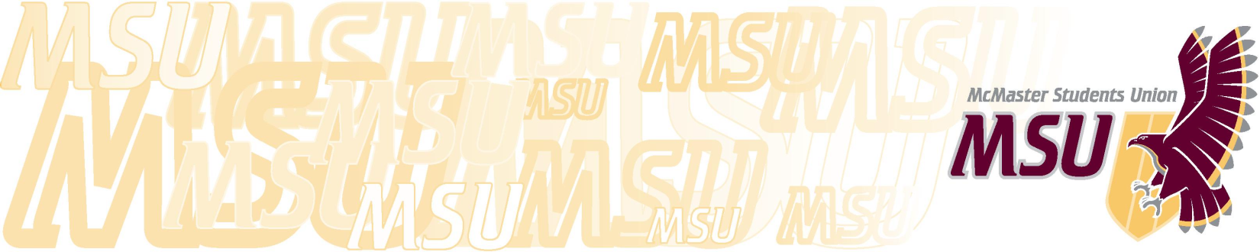
…

Operating Policy – Business Related Expenses

- Purpose

  - To provide guidelines for expenses incurred by SRA members, Committee members, and employees performing their duties as members of the organization. This includes but is not limited to travel to and from meetings, conferences, or other official MSU business subject to budgetary provisions approved by the SRA.

- Operating Parameters

  - Meetings shall be defined as duly constituted meetings of MSU boards, committees, or the SRA called for the purpose of conducting MSU business;

  - Official MSU business shall be defined as that business which has been delegated by an immediate supervisor, is explicit in a job description or department’s terms of reference, or has received approval in advance from the SRA through budget allocations;

  - Conferences shall be defined as meetings of organizations to which the MSU holds affiliation;

  - Any circumstances not covered by this policy shall be subject to a decision of the Executive Board.

- Meetings

  - Reimbursements for attending meetings of committees and of the SRA are subject to the following:

    - No food allowances or per diem shall be given to anyone attending a meeting of the SRA or a committee meeting;

    - Summer Travel Expenses:
      - For distances within 500 kilometers of the meeting location, reimbursement will be made for the most inexpensive efficient mode of transportation, if approved by the Executive Board;
      - For distances over 500 kilometers, reimbursement may be requested of the Executive Board in advance of the meeting;
      - Travel expenses will be reimbursed by cheque upon submission of receipts to the Vice-President (Finance).

    - Academic Term Travel Expenses:
      - Travel to and from committee meetings and meetings of the SRA during the academic term will not be reimbursed.

- Business Expenses

  - Travel on official MSU business shall be reimbursed according to the following formula:

    - Individuals shall be fully reimbursed for the most inexpensive and efficient mode of transportation;

    - Individuals who travel by a non-rental car will receive $0.37 cents/kilometer;

    - Parking expenses will be fully reimbursed when supported with a receipt;

    - The MSU will not pay or reimburse expenses for parking tickets or traffic violations;

    - Under special circumstances, members who are required to handle MSU business off-campus and have no automobile transportation may use a taxi slip, authorized by their immediate supervisor.

  - Use of a technological devices for official MSU business shall be reimbursed according to the following criteria:

    - Board of Directors and the General Manager will be reimbursed $80 a month for their use of their cell phone ;

    - The Campus Events Director, Network Administrator and Student Life Development Coordinator will be reimbursed $60 a month;

    - The Underground Manager, AVTEK Technical Coordinator, Silhouette Executive Editor, and the Food and Beverage Manager will be reimbursed $40 a month;

    - The CFMU Programming Director and AVTEK Office Manager will be reimbursed $20 a month.

    - Under special circumstances, the Executive Board may approve additional staff or volunteers reimbursements. This approval must occur before costs are incurred. If an emergency warrants incurred costs, the matter must be brought forward at the next at meeting. Failure to do so will result in no payment of the expense by the MSU.

    - All reimbursements are contingent on the employee owning, and using a cell phone device for work purposes.

- Taxi Slips

  - Taxi slips will be issued for the following purposes only:

    - Employees and or volunteers asked to stay beyond their regular shift, provided that public transportation is not in operation;

    - Sending intoxicated patrons home from a licensed establishment;

    - Trips for business purposes for managers (signing authorities);

    - Tip shall be no more than 15% of the fare.

- Reimbursements

  - An employee will be reimbursed for expenses relating to meals while on a conference on behalf of the MSU;

  - Employees who have an expense account will be permitted to expense meals provided that the purpose of the meal was to conduct business with a client or associate;

  - No reimbursement will be made for the purchase of alcoholic beverages, unless approved by the Executive Board;

  - Tips shall be reimbursed to an amount not exceeding 15% rounded up to the nearest dollar of the total bill (less alcoholic beverages) before taxes.

  - Employees requesting reimbursement will be required to submit a cheque requisition and expense report with all itemized receipts attached to the Vice-President (Finance);

  - No reimbursement will be made for expenses which are more than sixty (60) days old;

  - All policies with respect to Purchase Orders and advance approval will apply to those employees who do not have an expense account.

- Conferences

  - MSU delegates to conferences shall have their travel and accommodation costs paid in full by the MSU. This shall be arranged by the immediate supervisor and shall be in accordance with current office procedures;

  - Transportation to and from airports, bus stations, and other like locations shall be reimbursed upon submission of receipts to the Vice-President (Finance);

  - Delegates whose food is not accounted for in the conference fees shall receive up to $50 per day with itemized receipts, a cheque requisition, and an expense report.

