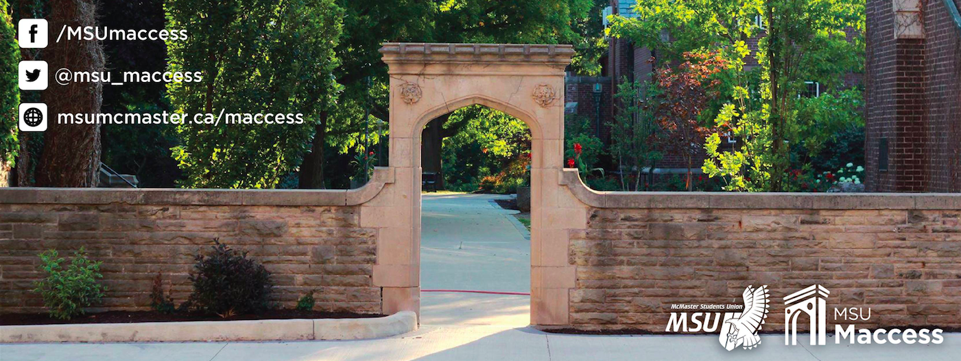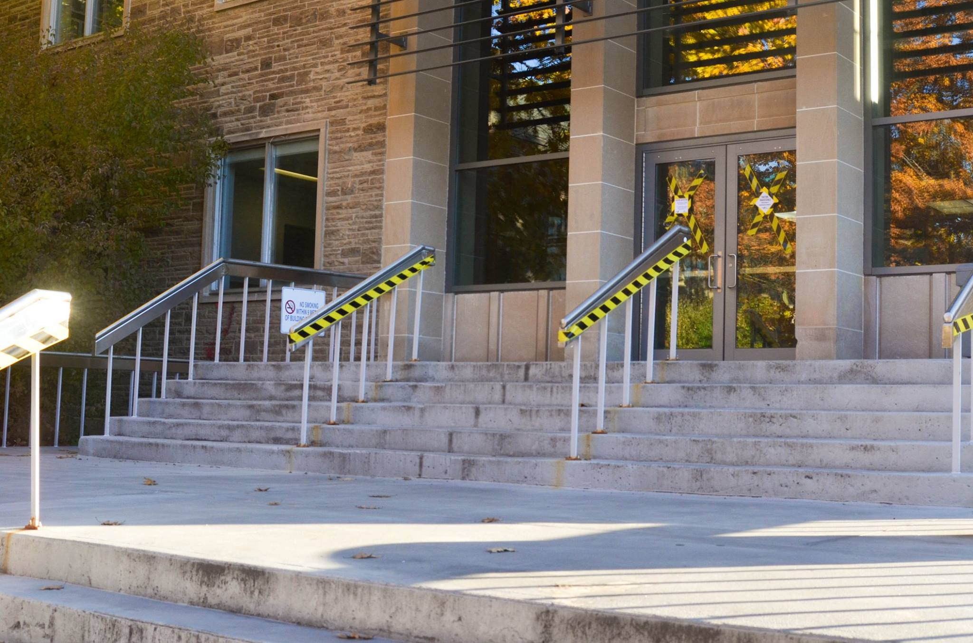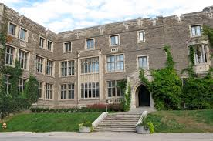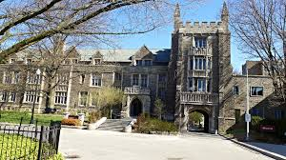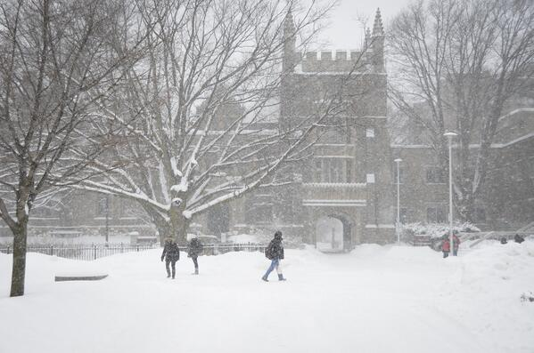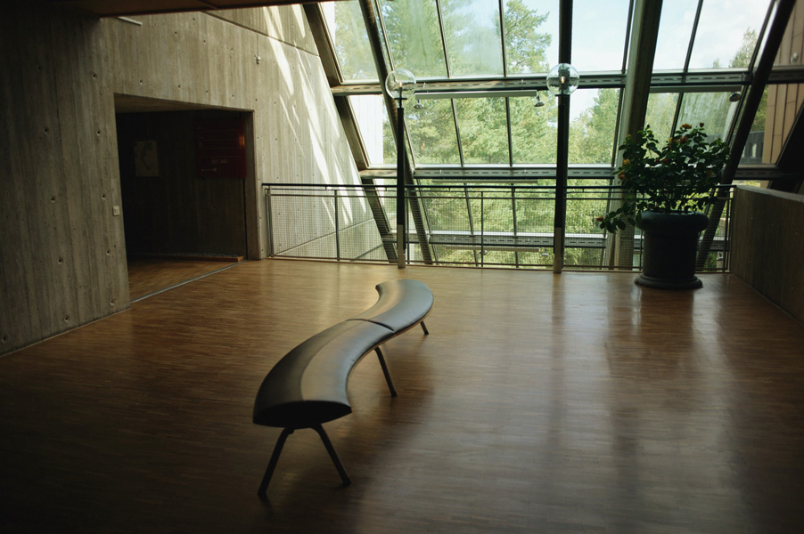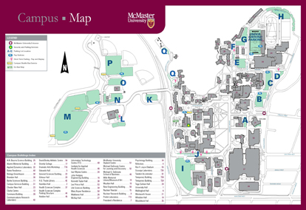

2016-2017

McMaster Accessibility Guide

One useful way to check the accessibility of various areas of campus is with this map—it contains information about which buildings are accessible through which doors, and can be very helpful for planning routes. If you (like me!) have trouble with maps, here are a few lists of buildings and areas that can prove troublesome for students with mobility concerns.

Inaccessible/Partially Accessible Buildings:

**Burke Science Building:** BSB’s main entrance on the BSB field is inaccessible, and the accessible entrance can be hard to find. There are a number of slightly misleading entrances around the side with wheelchair stickers or ramps—avoid these! The fully accessible entrance is around the back, at the back left corner close to the walkway between BSB and JHE, the Engineering building. It has a ramp leading down to the basement, where there is an elevator to access the main floor and other floors.

Physical Accessibility on Campus

Hello! Chances are you’re reading this either because you are new to the McMaster campus and you use a mobility aid, or you go to McMaster and are newly using a mobility aid. This is a short guide intended to answer some questions about accessibility on campus and hopefully provide information that typically only comes from experience- things like what areas on campus are difficult to navigate, which elevators commonly break down, and who to call with accessibility issues. There will hopefully be further editions of this guide as we collect more information, so please contact MSU Maccess with any questions, suggestions, or feedback!

Introduction

Other Important Partially Accessible Locations on Campus:

**Campus Store:** to get to the Campus Store without using stairs, you have two options. You can either use the ramp from the outside, which is outside of MUSC near the Starbucks, or can go through the basement corridor of Gilmour Hall, which can be accessed through the Arts Quad basement level. When buying textbooks, students typically have to line up near the staircase to CNH—this entrance requires stairs, so you will need to enter through one of the other entrances.

**Bridges:** to get into Bridges without stairs, you need to use the side accessible entrance beside Wallingford Hall. The lift to get down into Bridges is found on the left of the hallway leading to the Phoenix. (Currently, the construction means you have to walk to Keyes to get to the ramp to the side entrance!)

**Centro:** to get into Centro without stairs, you will need to use the Commons lift, which requires a key from the info desk.

Partially Accessible Buildings Continued

**Hamilton Hall:** HH’s main entrance is also inaccessible. The accessible entrance is easier to find—it is through the doors with the ramp on the leftmost side of the building near the greenhouse.

**University Hall:** UH’s main entrance is also not accessible. The accessible entrance is around the side, near Hamilton Hall, which takes you to an elevator to access the other floors. As well, to access rooms 115-130, students in wheelchairs will need to use the stairlift, which requires procuring a key from the Religious Studies office in room 104, near the elevator.

**Gilmour Hall:** Gilmour Hall is inaccessible from the outside. To get in, you either need to use the Arts Quad basement corridors, the doorway on the second floor of MUSC, or the entrance on the South side of CNH.

**HSC/MDCL/LSB:** in the hallway connecting these buildings, there are no push buttons to automatically open the doors.

**Divinity College:** the accessible entrances are around the back, accessed through the parking lot by MDCL. Inside, you need to use a lift to access all floors but the basement.

Partial List of Inaccessible Classrooms:

This is a list of all the classrooms Maccess volunteers found that were inaccessible—for example, some do not have accessible desks, some require stairs, and some have heavy doors without push buttons.

* **KTH B104, B105, B134, B136 (and likely other basement tutorial rooms)**: these basement tutorial rooms have raised floors and desks with attached chairs, meaning there is little to no room for students with wheelchairs or scooters.
* **DSB basement classrooms:** no accessible desks
* **HSC 1A1, 1A6:** no accessible desks—areas that say “reserved for wheelchairs” at the front, but without desks.
* **BSB 147:** this lecture hall has no accessible desk
* **LS B130:** although there are elevators to the basement, you need to climb a set of stairs to get into this classroom.
* **HSC anatomy lab:** no push buttons to get in
* **ABB 271** has no accessible desks

Lifts that require keys:

* University Hall stairlift
* Gilmour Hall elevator
* Stairlift in MUSC to Campus Store
* Divinity College lift
* Commons Testing Centre
* Bridges
* Centro (Commons Lift)

**NOTE:** All of these lifts are a bit unreliable and often break down. When using the lifts, make sure you don’t let go of the button the whole way, otherwise you may get stuck inside!

Difficult Pathways:

* The courtyard outside BSB can be challenging to navigate in a wheelchair
* With the current construction, the area by JHE is sometimes obstructed and blocks the ramp.
* The paths on the way to Commons can be challenging to navigate in a wheelchair
* The sidewalk just past the walkway to MDCL has a lot of cracks that are difficult to get over, and the walkway itself is slanted
* The sidewalk outside DSB has some large sidewalk cracks that can be problematic for wheelchairs

These issues may be resolved soon, but at the time of writing, these construction issues are affecting accessibility on campus:

* The automatic buttons on new doors to MUSC are not working
* The construction outside of JHE blocks the pathway outside from BSB, as well as the crosswalk from the Psych building
* The Phoenix’s main entrance is under construction but blocks off the path, so to get to the accessible entrance, you have to get on the ramp by Keyes
* One accommodation you can register for through SAS is wheelchair accommodated testing
* When you have this accommodation, your exam schedule on MOSAIC will be changed to ensure that all of your exams are in accessible locations
* SAS has 3 testing centers in the Commons basement, which requires a key to access—these have powered height adjustable tables to accommodate various mobility needs

Exams and Testing Accommodations

On-Campus Resources:

**Facility Services: 905-525-9140 x 24740**

If you run into accessibility issues on campus, Facility Services is usually the best place to call. For example, if a wheelchair ramp is not plowed, if a push button is broken, they will be able to assist you.

**Security Services: 905-525-9140 x 24281**

Security Services can also assist with some accessibility issues—for example, if you do wind up getting stuck in a lift, they are a good place to call!

**Student Accessibility Services: 905-525-9140 x 27552 (MUSC B107)**

To access any needed academic accommodations, you can make an appointment with Student Accessibility Services

**Equity and Inclusion Office: 905-525-90140 x 27581 (MUSC 212)**

If you have complaints or accessibility issues, you can take them up with the Equity and Inclusion Office

Current Issues On Campus

Surviving Winter On Campus

Winter can be a particularly challenging time for mobility aid users on campus—snow can be a real hassle. Here are a few tips and suggestions to make surviving the snow a little bit easier.

Snow:

* If you regularly find your paths to class are not plowed, you can send your schedule to your SAS Coordinator, and they can pass it along to Facility Services to ensure they are plowed for you
* If ramps and paths are NOT plowed when you need them to be, call Facility Services at 905-525-9140 x 24740
* When all the snow melts, it sometimes forms Lake McMaster all over the BSB courtyard, while makes that whole area inaccessible. They now should be draining it so it will hopefully be less of an issue, but still something to be aware of.

Indoor Pathways:

* CNH, KTH, TSH, DSB, and MUSC are all connected through underground passages in the Arts Quad basement
* There is a bridge that connects MDCL and HSC on the second floor (although without automatic push buttons!), again to avoid needing to traverse through the snow.
* Various North Quad residences connect to the Commons Building/Centro through an underground tunnel but there may be stairs to get to the underground connection

**Cool Resource: Cartographr App**

This is an app aiming to provide accessibility notices and warnings to McMaster students. In the app, you can see a map of the McMaster Campus, and either flag accessibility issues and hazards yourself, or check to see what others have posted—things like blocked ramps, large sidewalk cracks, or obstructed pathways. The more people who use the app, the more data there is, so the more useful it is!

Accessible Parking On Campus

To park on campus in designated accessible spots, you will need both a MTO Accessible Parking Pass, as well as the McMaster Accessible Parking Pass. The McMaster pass can be purchased through Parking Services, and costs 48$/month, allowing you access to any on-campus lot, minus those reserved for faculty. Typically undergraduates are restricted to purchasing passes only in Lot M, which is far away and down a hill, with intermittent shuttle service, which does not run on weekends, but with the MTO pass, you can purchase this alternative.

The Parking Services office in the E.T. Clarke Centre is not accessible, as there are stairs to get into the door and into the office. They have recently opened another counter in the Campus Store as well, where you can also purchase parking passes on Monday-Friday from 9-4.

All of the on-campus lots have designated accessible parking spots, with some filling up more frequently than others. There are also additional accessible spots outside of Mills   
Library and outside of IAHS on the road.

Nam nec dui vel sapien semper sollicitudin. Curabitur dui justo, venenatis a, pharetra vitae, ultrices in, velit.

Sports and Recreation

Mac has a number of accessible intramural sports options throughout the year. Sports that would be accessible for those with mobility impairments include a Wheelchair Handball tournament in the winter, and a Sitting Volleyball league during the fall.

More information can be found here: <https://rec.mcmaster.ca/programs/intramural-sports-0/sports-everyone>

As well, sport wheelchairs and an all-terrain wheelchair are available to be signed out from DBAC (Mac’s Gym).

Note: this just includes single stall accessible bathrooms, not stalls within standard washrooms

Libraries

Most of the libraries’ bookstacks (especially Mills, Health Sci, Thode) do not have enough room to maneuver a wheelchair between the shelves. To avoid this, you can contact the library in advance, and they can collect your books for you instead. Alternatively, if you go to the help desks at the front, you can request someone to come with you to assist.

Accessible Washrooms

* ITB: 119, 104, 105, B103, B104
* IWC: 102/E, 111A, 113, 128/A, 129/A, 202, 203, 107, 108
* KTH: B125A
* LSB: 101
* Mills: 213/C
* MUSC: B114
* PC: 154A
* Thode: B126
* TSH: 320
* UH: 108, 313, B109/A
* ABB: 103, 203, 303, 403
* BSB: 130, 128, 228, 318, 321
* CNH: 506
* Commons Building: B1110
* DBAC: B102, B103, 107, 108
* DSB: 330
* ETB: 128, 221, 222, 232, 304, 305, 531
* GH: 111
* GSB: 109
* HSC: 1JW01, 1JW02, 3NW01, 3NW02, 2BW03

About Maccess

This accessibility guide was produced by volunteers with Maccess, McMaster’s new service specifically for and by students with disabilities! Maccess focuses both on advocacy efforts to do with disability and accessibility, as well as building a community and providing support for students with disabilities and disabled students.

If you would like to get involved with Maccess, you can find us on facebook at MSU Maccess, or can stop by our space coming in 2017 in MUSC B111.

Hopefully, as we build more collective knowledge, we will be able to produce further editions of this guide with more updated information. If there are any additions you would suggest, or if you have any comments about the contents of this guide, we would love to hear your thoughts! If you have any feedback, please contact the Resources Executive of Maccess at: [maccessresources@msu.admin.mcmaster.ca](mailto:maccessresources@msu.admin.mcmaster.ca)

Ultimately, the aim of this guide was to pass along and preserve knowledge that various Maccess volunteers have learned through personal experience of navigating the McMaster campus while using a mobility aid. We hope that it is an accurate, information, and helpful resource for you! Again, please feel free to contact us if there are additional resources that you would find beneficial, or if you have corrections, suggestions, or additions to the material here.

Thank you for reading!

Ali Imrie, Maccess Resources Executive